**MODULE: 3.1 (C Language Fundamental)**

1. Display This Information using printf

1. Your Name

2. Your Birth date

3. Your Age

4. Your Address

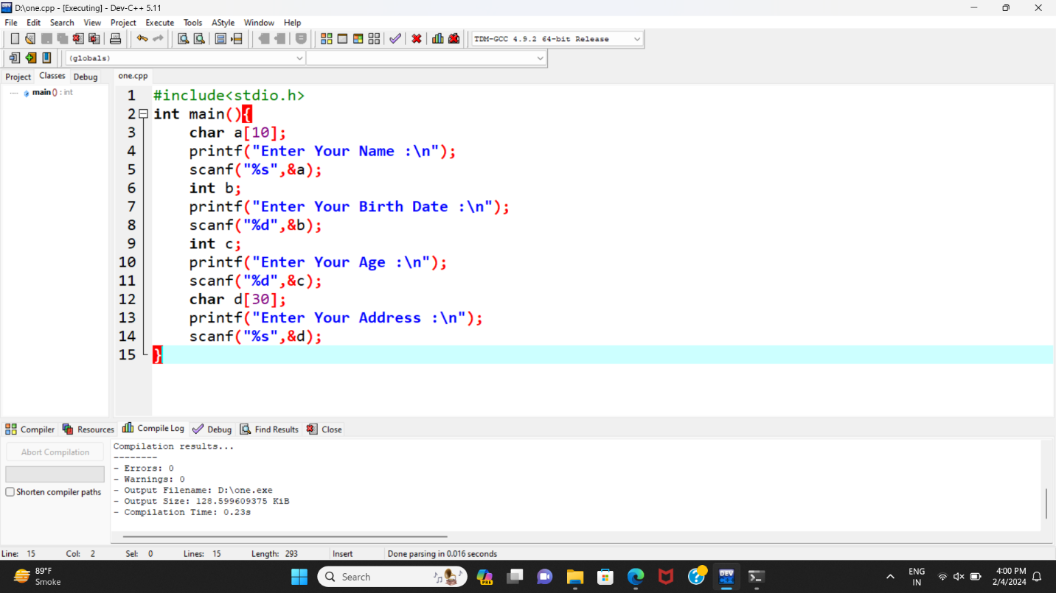

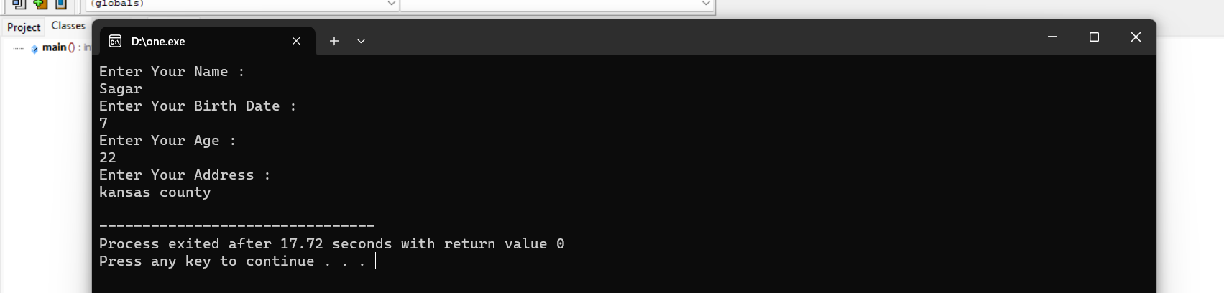

1. Write a program to make Simple calculator (to make addition, subtraction, multiplication, division and modulo)

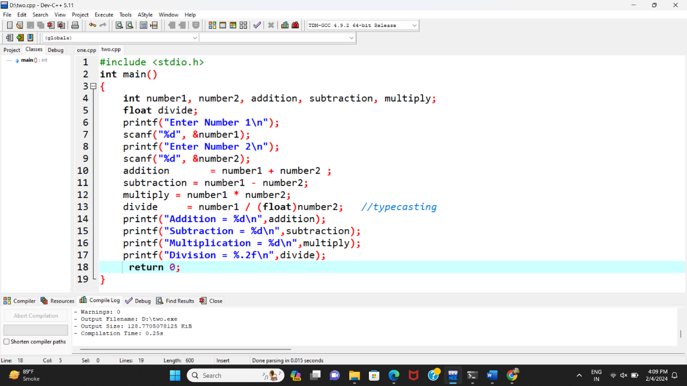

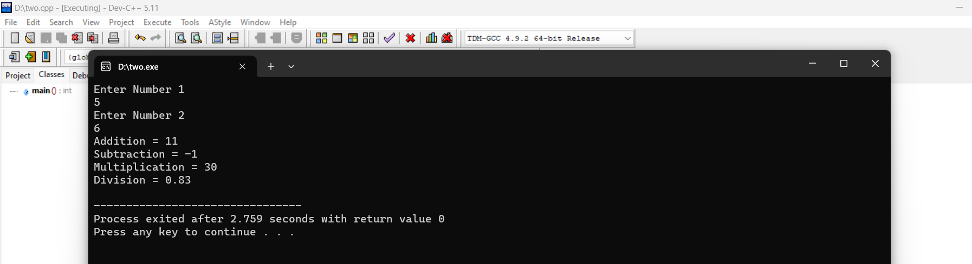

1. WAP to find area of circle, rectangle and triangle

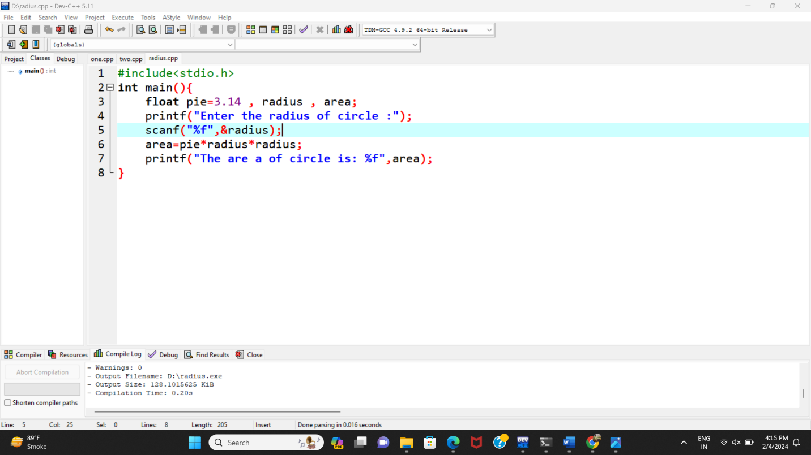

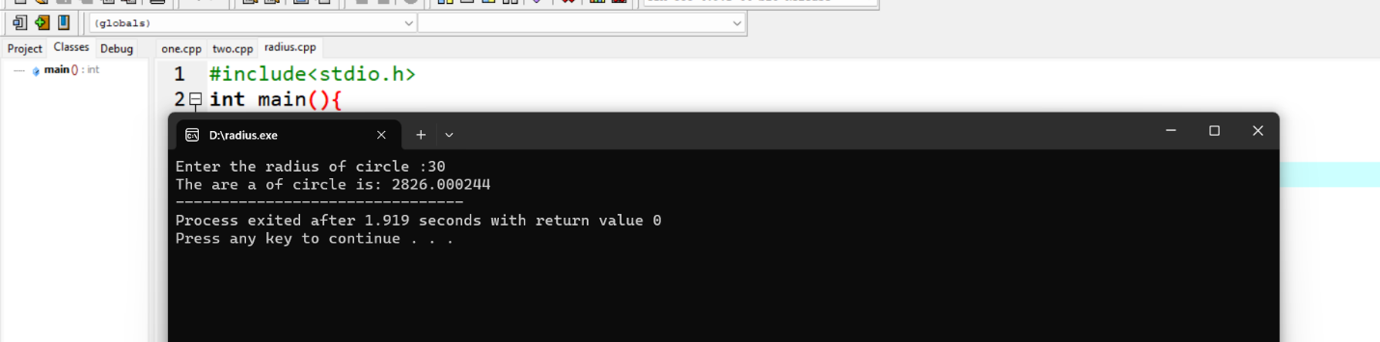

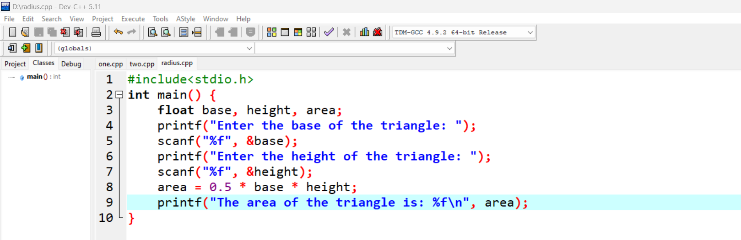

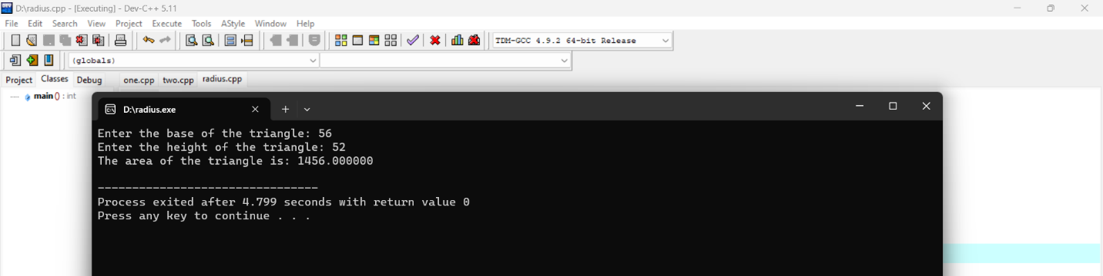

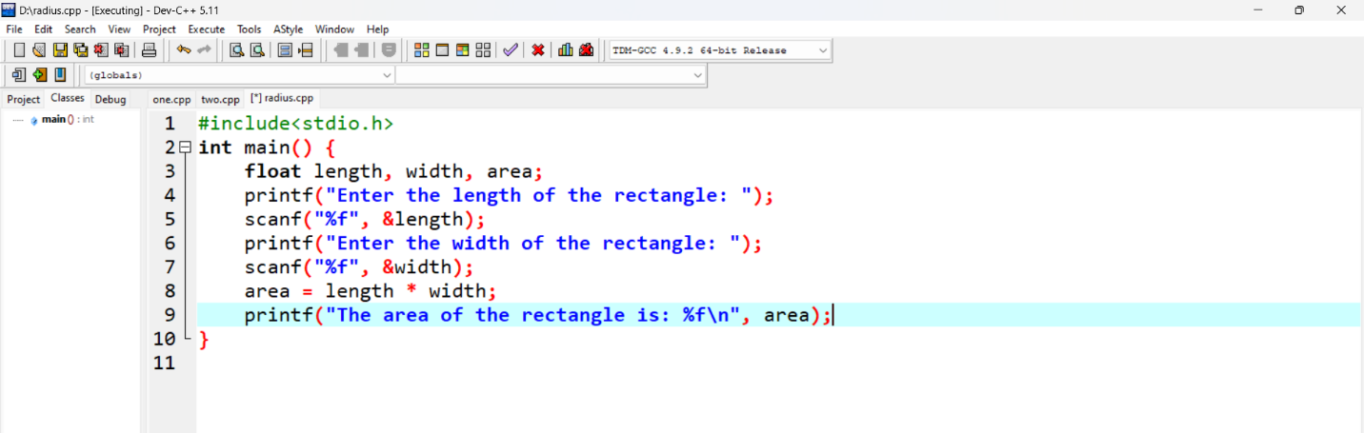

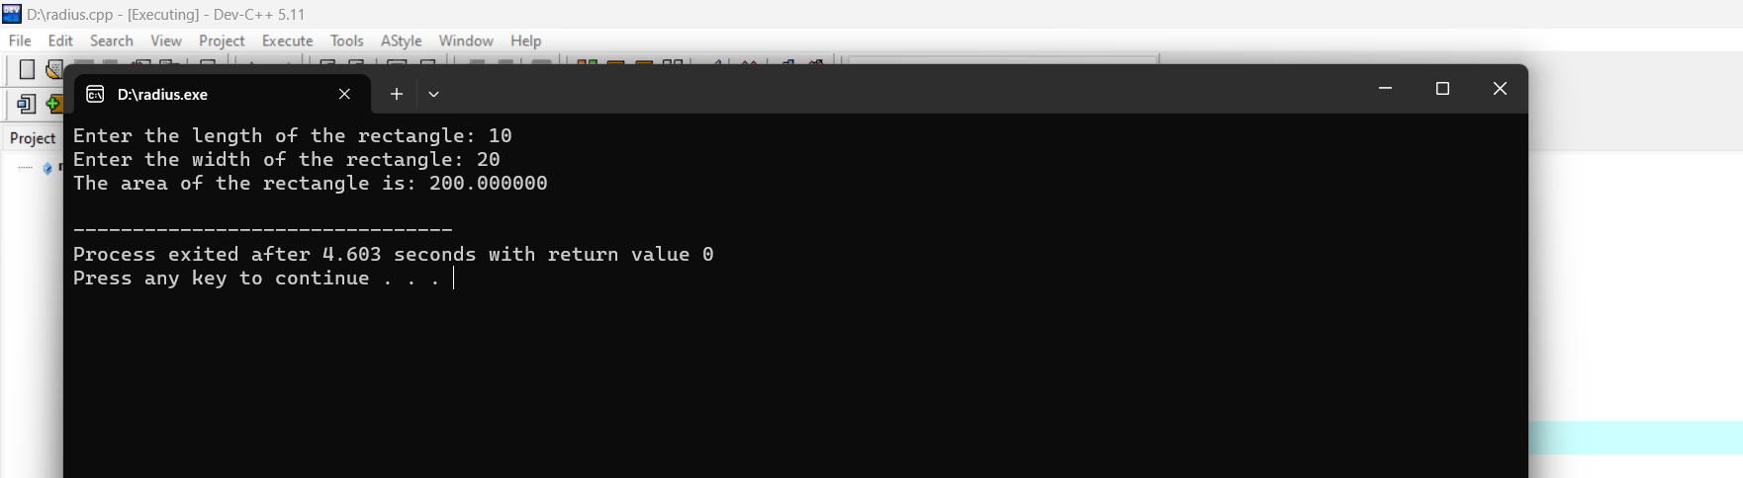

1. WAP to find simple interest

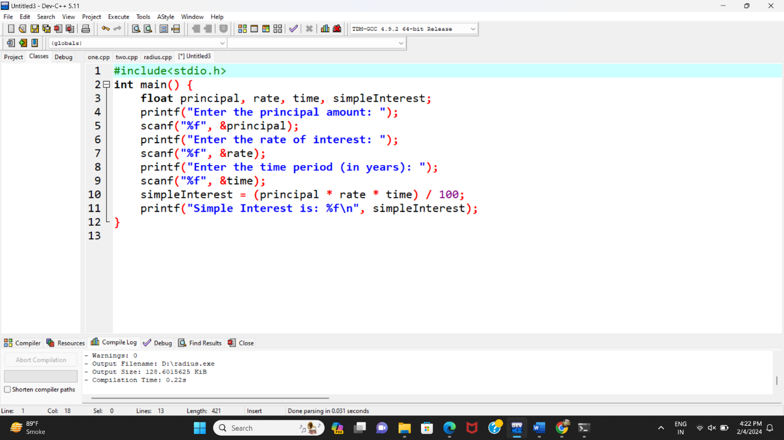

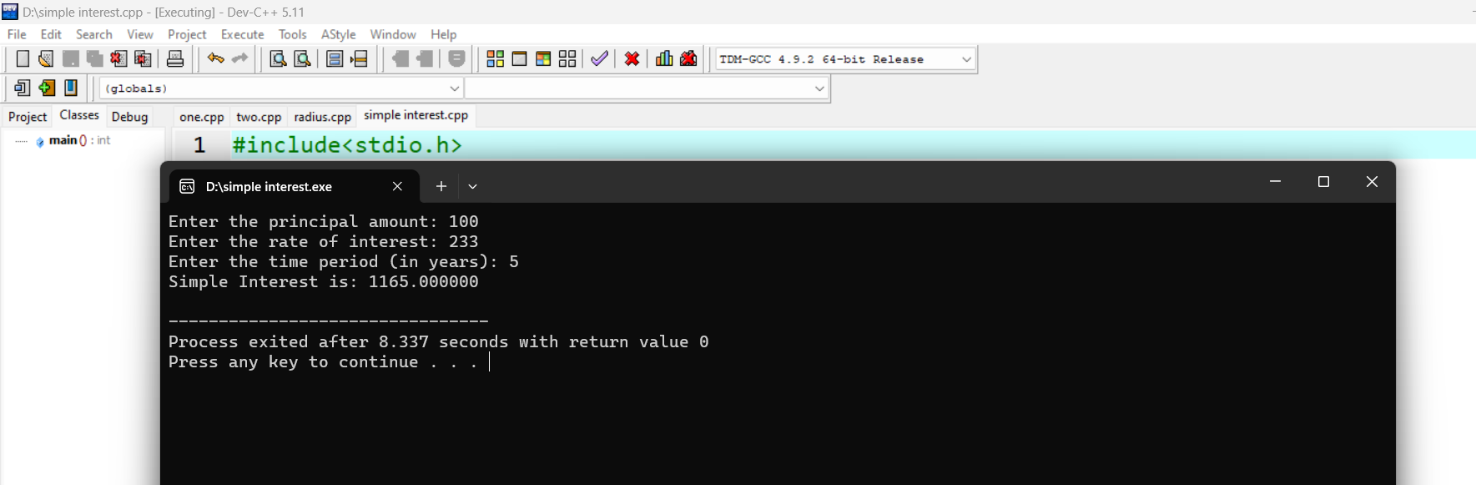

1. WAP to check if the given year is a leap year or not.

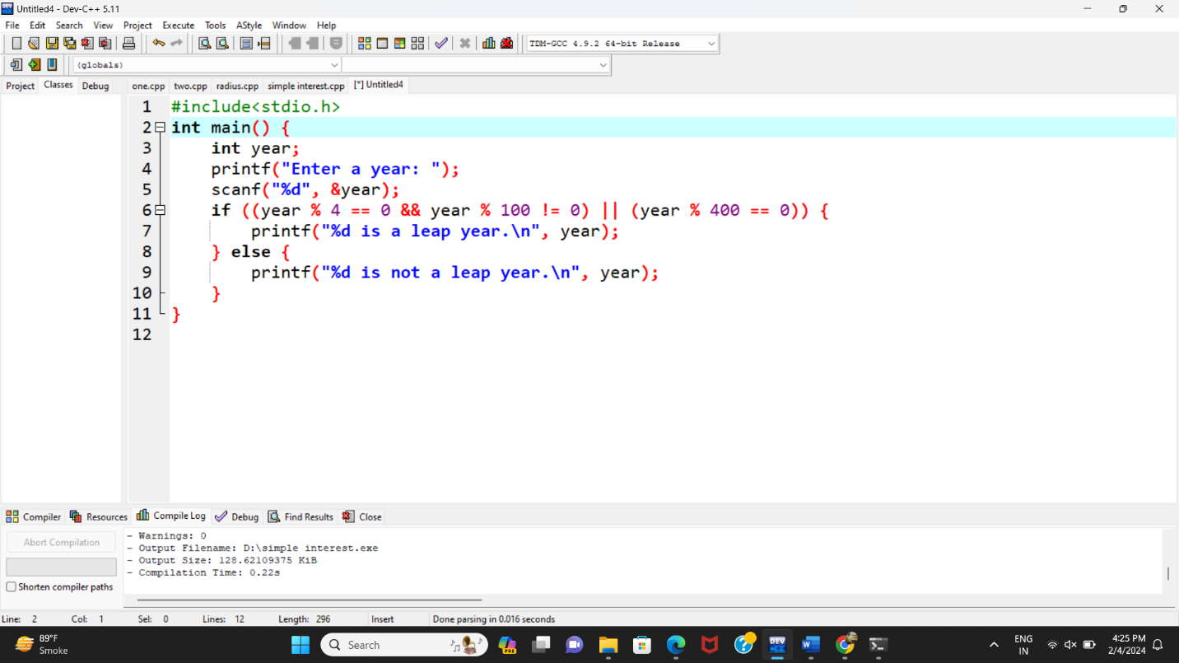

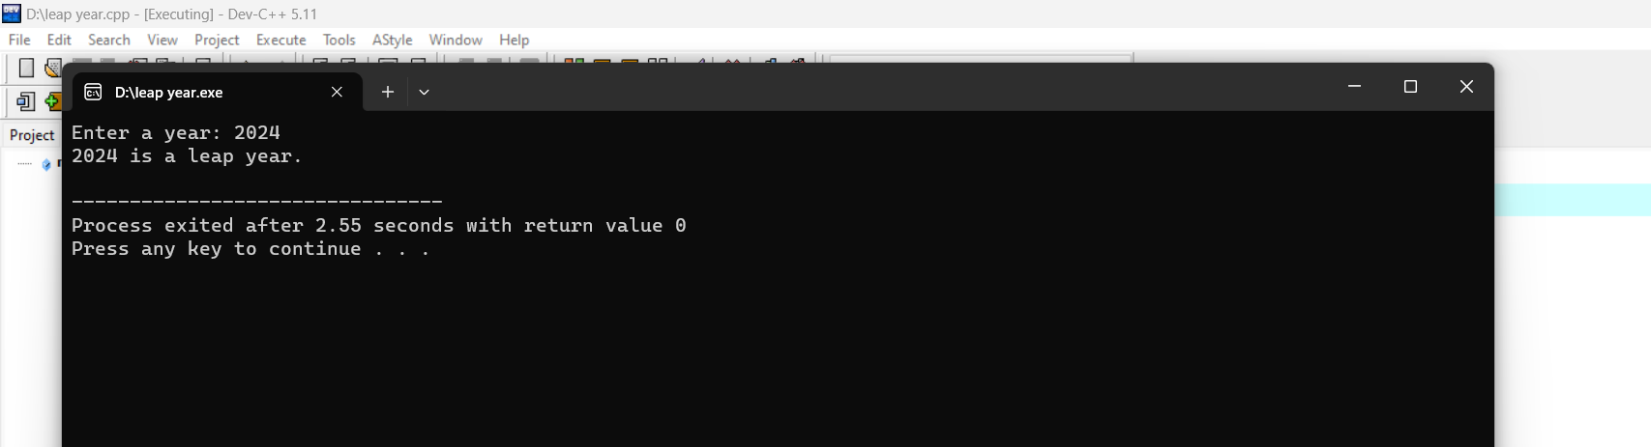

1. WAP to convert years into days and days into years

